Basic Databases – Report02
Wroclaw University of Technology, Date: October 26, 2018
Student: | Email: ---------------------------------------------------- | Grade
Identifier
First name
Last name
This task consists of 2 problems. If you cannot solve a problem, try to give at least a partial answer or partial solution. Remember to write your name, and identifier.

Problem 1
Based on the developed conceptual data model "Books" in previous lab classes:
- Define the structure of the database (tables, constraints: PRIMARY KEY, FOREIGN KEYS, CHECK - domain constraints
- Introduce sample records to check the correctness of defined constraints

Solution:

Problem 2
- Define conceptual data model based on the following relational database schema (Company relational data model) using UML
- Implement the Company relational database in MS SQL 2017
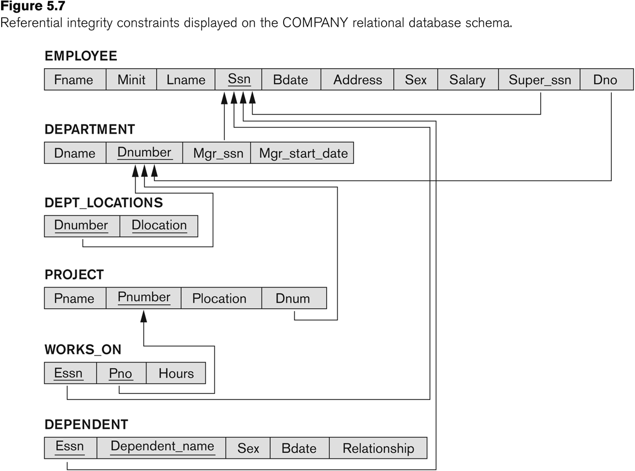

Solution:

Conclusions
?

----------------------------------------------------------------------------------------------------------------------------
Please do not forget about the conclusions being a summary of considered problems and proposed solutions!
Remarks:
- Students' reports (as one package) should be sent by the leader of the group via e-mail before the next lab
- The rule of naming student’s file report is defined below

Name of the file: Rep01-StudId-Last name.pdf | Example: Rep01-1951355-Turan.pdf

